Session 1 - Assignment 1

# Problem 1 :

a = input ("Enter a number ")

fact = 1

prn = ' '

for i in range(1,int(a)+1):

print(i)

fact = fact * i

prn = "Factorial of " + str(a) + " = " + str(fact)

print(prn)

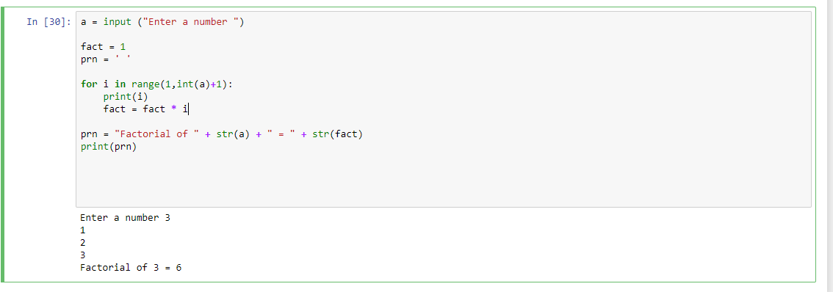

# Problem 2 :

num = []

for i in range(2000,3201):

if (i % 7) == 0 and (i % 5) != 0 :

num.append(i)

print(num)

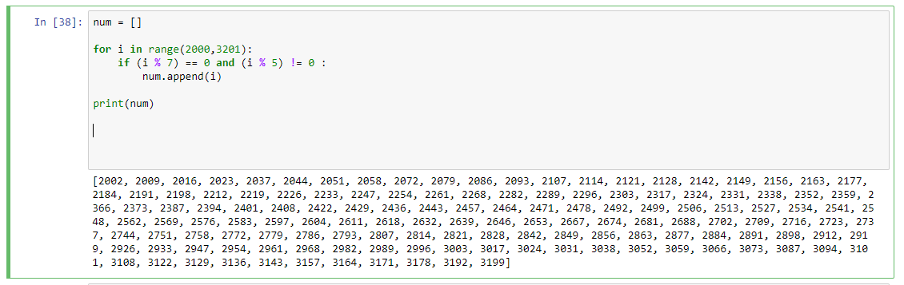

# Problem 3 :

fn = input ("Enter First name : ")

ln = input ("Enter Last name : ")

print(fn[::-1] + " " + ln[::-1])

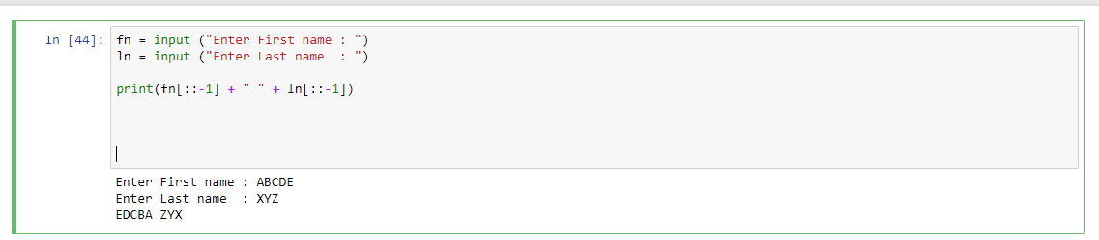

# Problem 4 :

diameter = 12

pi = 3.14159

v = (4/3) * pi * (diameter/2)**3

print(v)

